Yogurt Ice-Pops
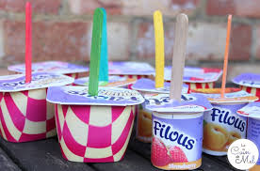
You will need:
- Petit Filous or favourite yogurt
- Lollipop stick
Method:
Take your favourite yogurt from the refrigerator.
Carefully cut a small hole on the top of the yogurt.
Place a lollipop stick in the hole.
Leave to set in the freezer for a few hours or overnight.

