St. Joseph’s Special School,
Thomas Hynes Rd, Newcastle, Galway.
Telephone 091 521895.
Email theoffice@stjosephspns.ie

Chairperson of the Board of Management: Audrey Pidgeon
Principal: Sarah McGinley

Timetable for Review
As necessary

7.2
Policy on Challenging Behaviour

Introduction
This Policy on Challenging Behaviour will operate in conjunction with the Code of Discipline and the Policy on Child Protection.
It is one of a range of tools used by the school to support teaching and learning.

Definition
Challenging behaviour within the context of St Joseph’s School is defined as that which:
- Prevents participation in appropriate educational activities
- Often isolates children from their peers
- Affects the learning and functioning of other pupils
- Drastically reduces their opportunities for involvement in ordinary community activities
- Makes excessive demands on teachers, staff and resources
- Places the child or others in physical danger
- Makes the possibilities for future placement difficult
(Harris, Cook and Upton, 1996)

See Appendix 1 ‘The Challenging Behaviour Matrix’ (2004)

Aims
The purpose of the policy is to:
- Create a climate that encourages and reinforces good behaviour.
- Create a positive and safe environment for teaching and learning.
- Build positive relationships of mutual respect and mutual support among students, staff and parents.
- Outline strategies to equip staff with the skills necessary for dealing with incidents of challenging behaviour with appropriate reactive strategies.

Philosophy
In line with best practice, the school adopts a proactive approach to dealing with challenging behaviour, by placing emphasis on the use of preventative strategies, while recognising the pupils’ personal integrity and rights.
An understanding of the factors that influence behaviour is fundamental to developing and implementing the policy. This understanding should be shared by staff and parents and where possible by the pupils. This will serve to create a whole school approach that is consistent and cohesive.
The school supports the theory that behaviour has meaning; it is not random; it serves a purpose; and has goals.
Staff make every effort to see incidents of challenging behaviour from the pupils’ perspective.

Causes/influences
While it is not possible to list all causes of challenging behaviour in this document, the most common influences are:
- Pupil’s physical state: illness, deficiencies or imbalances in body chemistry, hypo/ hyper sensitivity can sometimes be manifested by self-injurious behaviour.
- Communication difficulties: pupil may have difficulty interpreting the world around them or difficulty in conveying information which may give rise to feelings of frustration.
- Environmental effects: noise, light, heat or cold, space, seating etc may impact on how a pupil copes within an intended learning environment.
- Pupil’s developmental level: Self- control, emotional regulation, and problem- solving skills impact on a pupil’s behaviour.
- Lack of choice, boredom or inactivity may result in challenging behaviour
As reflected in the code of discipline a positive learning environment is achieved through the effective teaching of an inclusive and engaging curriculum.
Classroom management and teaching methods have a key influence on pupil’s behaviour.
The creation of consistent boundaries for behaviour and clarity on expectations for pupil’s behaviour is a critical factor in preventing problems. Planned classroom management is fundamental to this.

The following key aspects should be addressed:
- Predictability and consistency in the classroom- class rules, routines, schedules, time tables
- The classroom environment- use of space, seating, noise, light, and safety.
- The learning environment- learning styles, topic selection, co-operative learning, teaching approaches, and social and personal development.

Strategies
While the adoption of such preventative measures can do much to create a supportive learning environment, there may be occasion to employ further strategies to meet the needs of individual pupils.
These strategies may include:

- Active listening: A strategy designed to allow the pupil to have their point of view expressed and listened to in a non-confrontational manner.
- Big Toe First: A preventative/ management strategy which details in a step by step approach how to deal with incidences of challenging behaviour.

- Catch Them Being Good: A strategy which promotes the acknowledgement of appropriate behaviour or on task focus as an incentive for the pupil to repeat the positive behaviour. This can be used in conjunction with planned ignoring where attention for inappropriate behaviour does not serve as a reinforcer for the pupil.

- Social Stories: A strategy for assisting pupils who have poor social skills to understand and develop a range of social skills by presenting appropriate social behaviours in the form of a story.

- Behaviour Contracts: A strategy which specifies basic class rules and routines, the consequences that will accrue from abiding by these rules and routines, and the consequences for pupils on the occasions when these rules and routines are not followed. These contracts can be formulated on a class or individual basis as appropriate. Token Economy, Star Charts, and Golden Time can be used as part of this approach.

- Self-management: A strategy which aims to equip the pupil with coping skills in dealing with feelings of anger, frustration and anxiety.

- Replacement skills: Teach pupil to find a different way of responding/expressing need

* Resources in relation to these and other strategies are available in the SESS Resource Bank for Schools (2007)

Responding to persistent challenging behaviour
When a pupil continually displays difficult behaviour it is important for the family and all members of the multi-disciplinary team to be informed and to be involved in the development of a behaviour plan.
A referral may be made through the psychologist to the Ability West behaviour support services.
While the school recognises that pupils with severe challenging behaviour may need medication, it does not make recommendations to parents on the use of prescription drugs.
At the request of parents the school will furnish medical professionals with all relevant information on the pupil’s progress in school.

The Behaviour Plan
The plan should include the following:
Gathering Information
- Assess the pupil’s behavioural skills, deficits and excesses.
- Consider both internal and external contributing factors.
- List antecedents and consequences.
*Resources in relation to monitoring and analysing disruptive behaviour are available in the SESS Resource Bank for Schools (2007)

Interpretation
- Be aware of multiple causes. ( Appendix 2)
- Focus on how the situation feels for the pupil.

Intervention
- Decide on the most likely causes of the problem
- Specify the help the person needs
- Specify the help the carers need.
- Exclude, if possible, contributory external causes.
- Develop strategies for changing the environment, if appropriate.
- Build on the pupil’s strengths.
- Use negotiation, if appropriate.
- Agree on an individual behaviour plan.(see Appendix 3 for a sample of a behaviour plan)
*Copies of the Individual Behaviour Plan will be made available in each classroom.

Responding to a serious incident of challenging behaviour.

Occasionally, despite our best efforts, a pupil may engage in behaviour that is hazardous to themselves or others and may result in damage to property. In this instance staff must take steps to ensure the safety of all involved while attempting to support the pupil through the crisis.
In order to do this it is essential that all staff understand the phases of an incident.

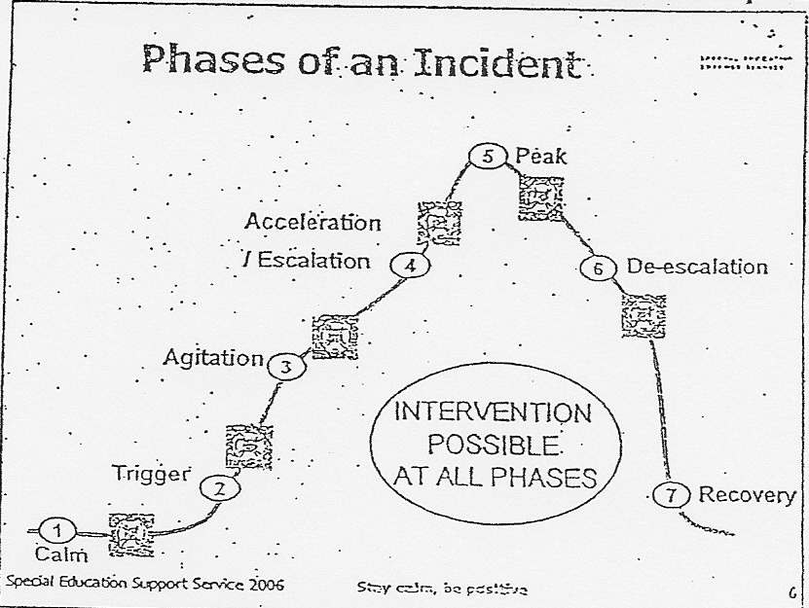

Guidelines for intervention.
The approaches outlined are intended as a guideline for staff in dealing effectively with a serious incident. It may be necessary to vary the approaches for individual pupils based on prior knowledge of the pupil’s pattern of behaviour.

- Trigger & Agitation: At this point the pupil displays anxiety. The staff approach should be supportive, empathetic and attempt to alleviate the anxiety. The trigger/ source of agitation should be identified if possible and removed if this is feasible.
- Acceleration/Escalation: Here the anxiety levels are heightened affecting the pupil’s self-control. The staff approach should now be directive- setting limits for the pupil and offering choices. Diversionary tactics can also be employed at this stage.
- Peak: At this stage the pupil has lost control and is exhibiting violent aggressive behaviour which is hazardous to themselves and others in the vicinity. The following steps should be taken:
  - Stay calm- breathe slowly
  - Keep a safe distance from the pupil.
  - Be aware of tone of voice and speak softly
  - Listen to the pupil.
  - Empathise: Acknowledge feelings
  - Depending on the situation remove the pupil or if more appropriate the other pupils in the immediate area.
  - It may be appropriate in some instances to leave the pupil alone and once safety is ensured monitor the situation from outside.
  - Use distraction if appropriate
  - Doing something unexpected or funny may change the mood.
  - In extreme circumstances it may be necessary to restrain or restrict the liberty of a pupil to prevent injury to him/herself or others. This should only be done as a last resort. Such measures should be discussed with relevant professionals and parents. (see a policy on restrictive practice)
  - If a behaviour incident persists over a long period it may be necessary to contact the family and/or other appropriate support personnel.
  - Risk assessment
  - Positive handling plan

See Appendix 4: De-escalating aggressive behaviours in People with Learning Difficulties (CALM training booklet)

- De-escalation: In this phase the pupil displays a drop in physical and emotional energy and begins to regain rationality and focus. Staff should aim to re-build communication and provide therapeutic care.

- Recovery: At this point the pupil has regained control of his/her behaviour. Staff should record any physical injuries sustained by anyone during the incident in the accident/ incident book and arrange for medical attention if required.
Individual staff involved in the incident should record the details of the event. A debriefing meeting for staff involved should be organised as soon as possible. At this meeting staff should reflect on how the incident was handled, provide emotional support for each other and decide if procedures need to be adjusted.(report template)

Repair & Rebuild

Following an incident of challenging behaviour it is important to sit down with the pupil and discuss what has happened. This encourages the pupil to reflect on:
- How the behaviour impacted on him/herself
- How the behaviour impacted on others
- Emotions/feelings at the time the behaviour occurred and the link between these feelings and the behaviour/action.
- Alternative, more appropriate ways of dealing with the emotions/feelings that triggered the behaviour.
- The Life Space Interview can be used as a means to repair and rebuild the relationship between staff and pupil after an incident has occurred. It is a strategy used to teach the pupil self-responsibility and to explore alternative/ replacement skills.

As it is important to avoid precipitating a reoccurrence of the challenging behaviour, discussion with the pupil should not take place until a calming period of time has elapsed (at least a day)

*Resources on these approaches are available in The SESS Resource Bank for Schools (2007).
Parental Involvement
The school recognises the need to work collaboratively with parents and carers in dealing with challenging behaviour. When developing a behaviour profile of a pupil, the following information will be obtained from parents and carers:
- The activities the pupil enjoys
- His/her likes and dislikes
- Method of communication
- Effective calming measures
- Incentives used to encourage good behaviour.
- It is essential that a consistent approach to managing behaviour be taken by all parties.
Roles and Responsibility
The Board of Management ensures that staff can avail of training on dealing with Challenging Behaviour.
In St Josephs there is a collective and legal responsibility to address issues in relation to challenging behaviour.
To meet this responsibility all staff need to be aware of their individual obligations to:
- Be familiar with school policy
- Adopt a proactive approach
- Be an active team member
- Avoid: - blaming others, unprofessional behaviour.
- Be assertive: -contribute, share views, listen actively and avoid negativity.
- Challenge: -bad practice, poor management, unacceptable pupil behaviour, staff failure to observe collective decisions.
- Learn: - from incidents, read about challenging behaviour, attend courses, discuss challenging behaviour with colleagues, seek advice.
- Be aware: - of risk, of your own needs/fears, of colleague’s strengths and weaknesses, of pupil needs/ stressors/ behavioural patterns.
- Be alert: - to management of foreseeable risks and gaps in protection policy.
- Follow: - school and agency policy, risk assessments, behaviour plans
- Seek support (CALM Training Booklet)

Implementation Date
This policy will take effect immediately following agreement by all stakeholders.
Timetable for Review
This policy will be reviewed as necessary, or in the event of new legislation, will be amended accordingly
A copy was included in the school plan as a reference for ancillary staff.

Timetable for Review
As necessary

Review and Ratification
The Board of Management is aware that this plan was reviewed in September 2020. The amended document was presented for ratification.

Signed: __________________________________ Date: ________________________
Chairperson, Board of Management

Signed: ______________________________________ Date: ________________________
Principal

