Step 1: Create a colourful Arctic backdrop. Consider using paint, colouring pencils, oil pastels or even chalk on black card. Here I’ve used regular ready-mix paint, layering blue, pink and purple across the white card stock.
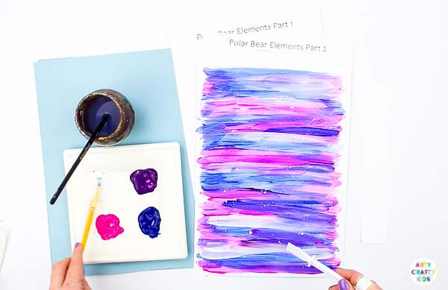
Step 2 Blend the blue, purple and pink by adding layers of white paint. Optional Extra – To create a snowy effect, use our controlled splatter technique to create white splats.
Step 3: Leave the Arctic backdrop to dry and cut out part one and two of the polar bear elements.
Step 4: Stick the large body element to the backdrop.
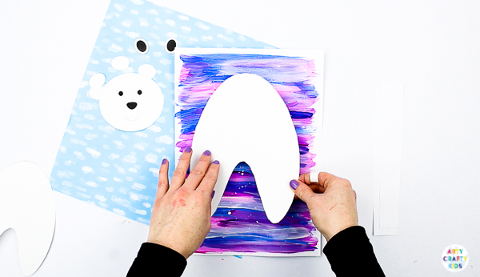
Step 5: Cut a strip of white paper from the short end of a piece of A4 paper. Cut this strip in half.
Fold the strip round and stick the two ends together to form a tube.
Stick the tube to the centre of polar bear’s body (as shown below)
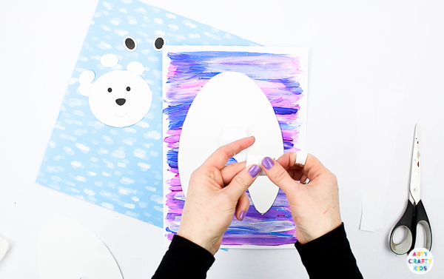

Step 6: Use the second strip to create another tube.
Step 7: Stick this tube to the leg (as shown below).

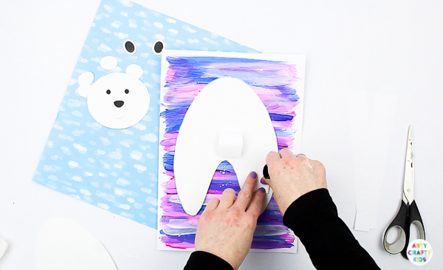
Step 8: Add glue to the back of the second body element and place it on top of the two tubes. Press down gently to secure.
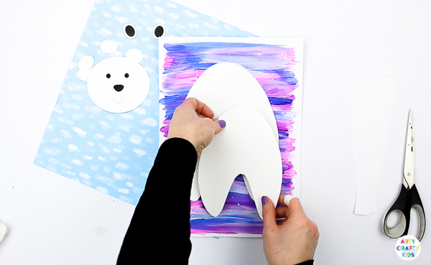
Step 9: Using scissors or a paper cutter, cut out two even strips of white paper – ideally, the strips will be fairly wide and for length, I would recommend cutting the paper from the shortest side of an A4 piece of paper
Take the two strips and position them in a 90° angle as shown above. Glue the connecting papers together.
Simply fold the bottom strip over the top and crease the fold along the edge. This will make the accordion fold tight!

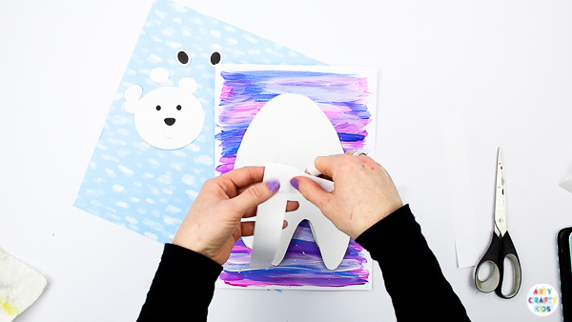
Step 10:
Keep alternating the strip folds until you run out of paper and seal the ends with glue.
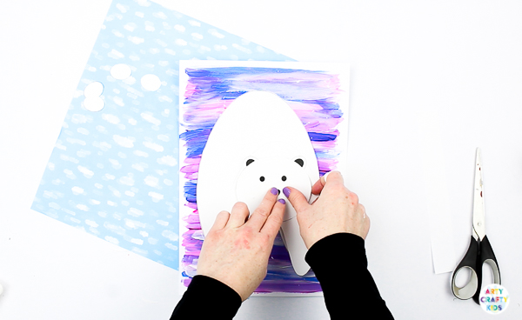
Step 11:
Stick one end of the accordion fold to the upper body element and glue the head on top. Complete the head with a pair of ears.
Step 12: With the polar bear now complete, the head will stretch and wobble, while the body parts can gentle bounce on touch.
