Healthy Picnic Lunch
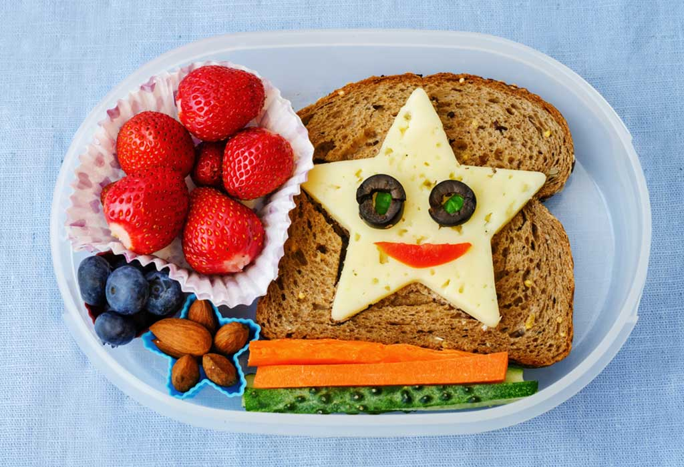
Why not try making a healthy snack for a picnic in your backgarden!

