Fruit Salad Ice-Pops
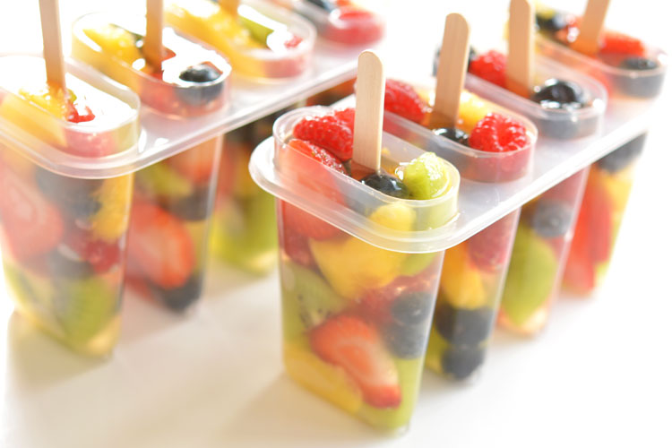
Ingredients:
Strawberries, Mandarin, Blueberries & Kiwi, Water or Apple Juice.
Method:
Cut up some fruits from the list above. Place them carefully into an ice-pop mould. Fill with some water or apple juice and place a lollipop stick in the centre of each. Place in the freezer for a few hours until set.

