Chocolate Brownies
275g (10oz) | butter, softened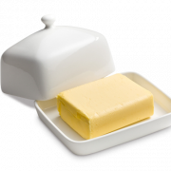
375g (13oz) | caster sugar
4 | large eggs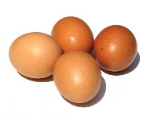
75g (3oz) | cocoa powder
100g (4oz) | self-raising flour
100g (4oz) | plain chocolate chips 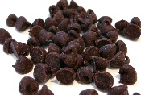

Preheat the oven 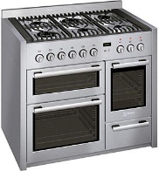to 180°C/Fan 160°C/gas 4.
Cut a rectangle of non-stick baking parchment 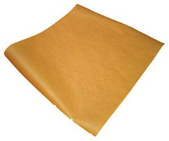 to fit the base and sides of a baking tray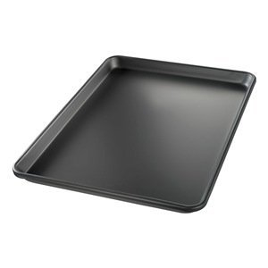.
Grease the tin and then line it with the paper, pushing it neatly into the corners.

Measure all the ingredients into a large bowl 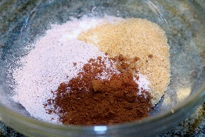and mix with a hand-held electric mixer 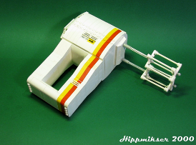until evenly blended. 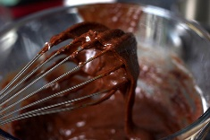

Spoon the mixture into the prepared tin with a spatula 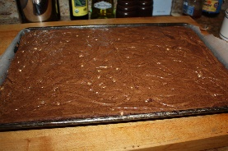.
Bake for 40–45 minutes. 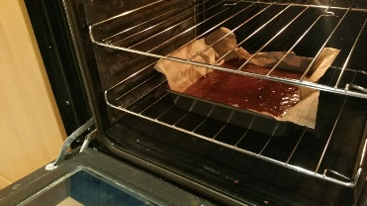
Allow the brownies to cool in the tin and then cut into squares and enjoy!!! 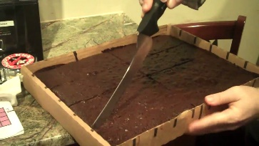
Yummy!!!!! 